**Document Upload Process for Pro Se Debtor**

**Purpose:**

This document serves as a guide for Pro Se debtors on the procedure for providing the Trustee with required case information via secure electronic upload to the Trustee’s office.

The Trustee’s Office uses an online service provided by BKDOCS (Formerly 13Documents) as a method to securely upload documents to the Trustee’s office. You will be required to register for an account with BKDOCS, which will require manual approval from the Trustees office before you are eligible to upload documents which may take up to 1 business day.

BKDOCS and the Trustee’s office take privacy of your personal information as highest priority. These documents will be fully encrypted and secured.

# Account Registration

1. 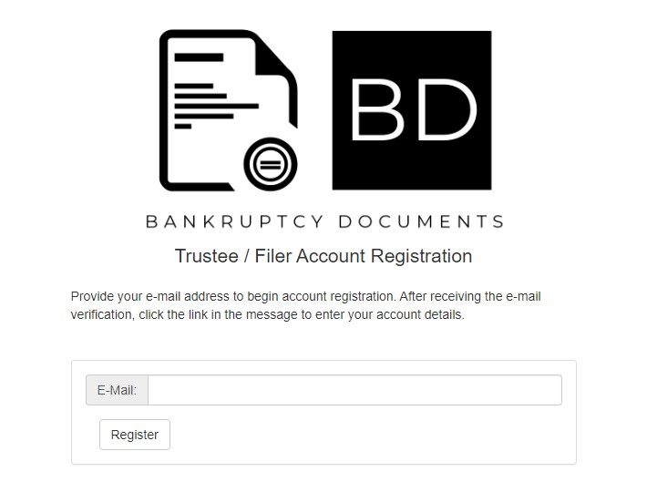Register for a filer account at BKDOCS by visiting https://www.bkdocs.us/account-register.html
2. Enter your E-Mail and click **Register**
3. You will receive an email at the address provided which you will use to finish setting up your account by clicking Confirm email address
4. On the Registration Details page, you will need to complete it as follows
5. Account Type: **Debtor**
6. Enter your First Name, Last Name and

Address, as it appears on your petition.

1. Enter a password and click Update

5. You will then be prompted to request Trustee Access.

Please click this option.

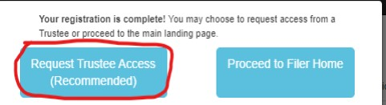

6. You will be presented with a long list of Trustee’s.

Please Scroll down and find **S.J. Beaulieu, Jr.**

# Click Request

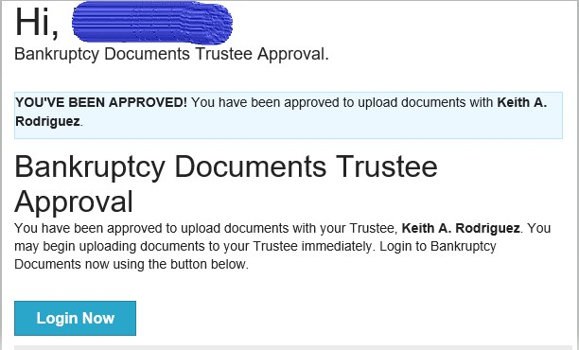7. You must now wait for the trustee to review your request which may take up to 1 business day. You will receive an email informing you that your account has been approved and then you can proceed to the next step. You will not be able to upload documents until you have been notified that your account is approved.



# Uploading Documents

Once your account has been approved, it’s now time to upload your documents to the Trustee

Note: You will need to have your documents already scanned and saved on your computer in a PDF format to complete these steps.

1. 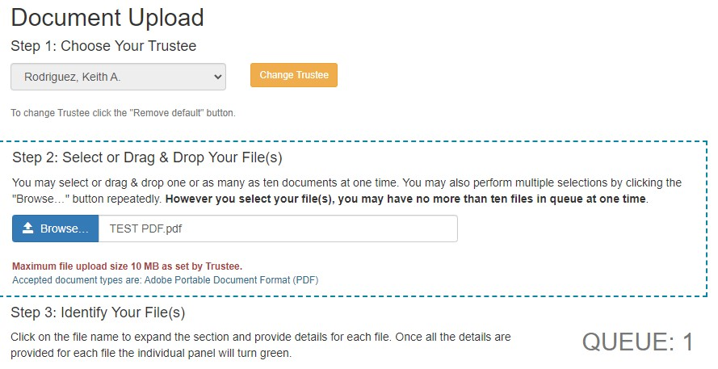Login to your BKDOCS account by clicking the link in the approval email or visiting https://www.bkdocs.us/login.php



1. Click **Document Upload** on the left side
2. Step 1: Choose your Trustee, select **S.J. Beaulieu, Jr.**



1. Step 2: Select or Drag & Drop your File(s) proceed to upload the PDF(s) of your required documents

5. Step 3: Identify Your File(s) enter your Case Number which you received when you filed your petition. Example 23-12345.

a. Your name should appear above the case number section if your case is found.

6. For Document Type, click the drop down and choose the appropriate type.

a. If you are uploading identity verification documents for your 341

# meeting of creditors, choose Social Security Card/ID [4430]

b. Tax Return for your last filed year must be redacted, meaning it cannot contain any full social security numbers, bank account numbers, or names of minor dependents. These are uploaded as **Tax Returns [4428]**

c. If you are uploading employment information, choose **Paystubs/Pay Advices [4429]**

d. If you were requested to provide bank statements, choose **Bank Statements [4431]**

e. If you need to provide any other personal documents, choose **Misc [4432]**

7. Review the Please Read section, check the box beside I accept once you accept the disclaimer, and click **Send** **Files**.